Locus at a Fixed Distance from a Line

Definition
# Source: AI Source: Provided by: [Data Path: Persons Table -> ID Column: 1, Name_En Column: Motasem Essam] -> From: [ChatGPT] on [7/25/2026]
The locus of points at a fixed distance from a line is the set of all points whose perpendicular distance from a given line is equal to a fixed positive distance.
Let $l$be a fixed line and $d>0$be a fixed distance. A point $P$belongs to the locus if:
$$\boxed{d\left(P , l\right)=d}$$
In a Euclidean plane, the locus consists of two parallel lines, each at distance $d$from the original line.
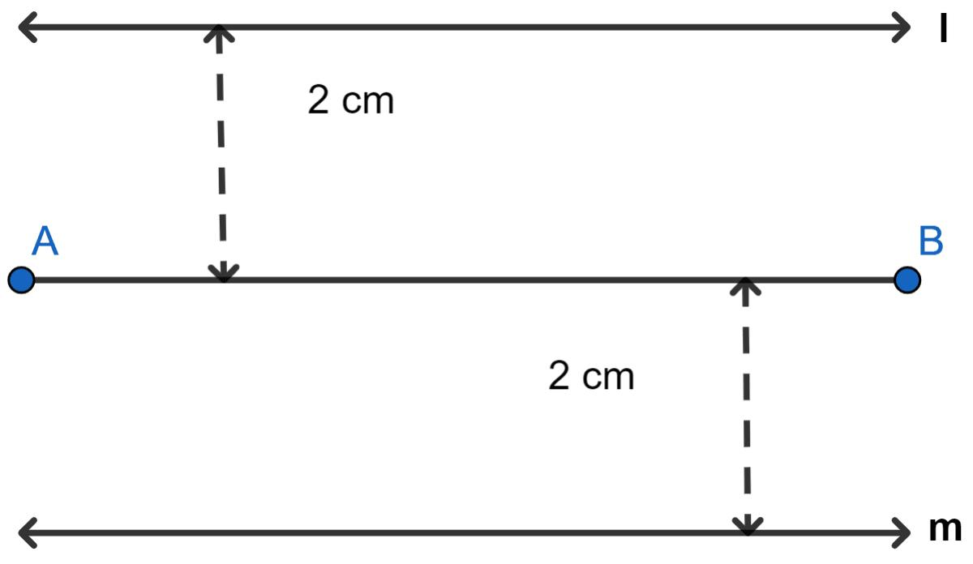
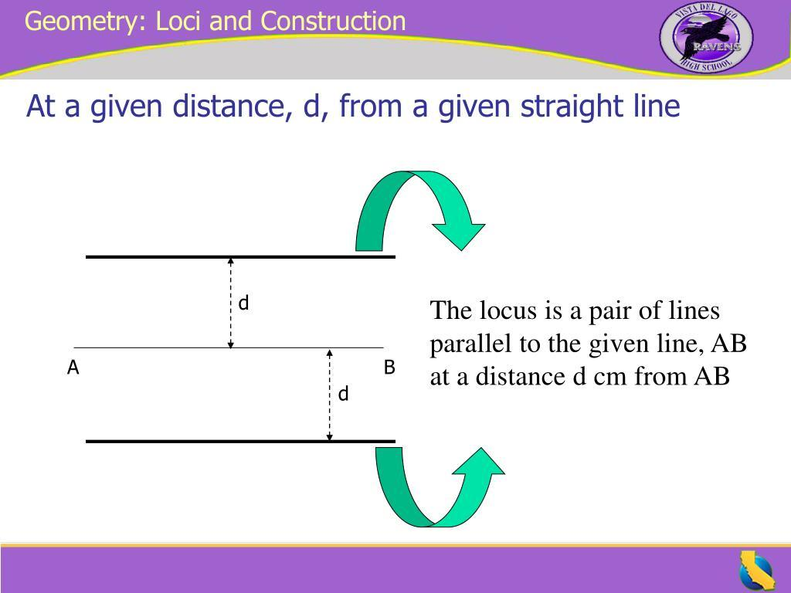
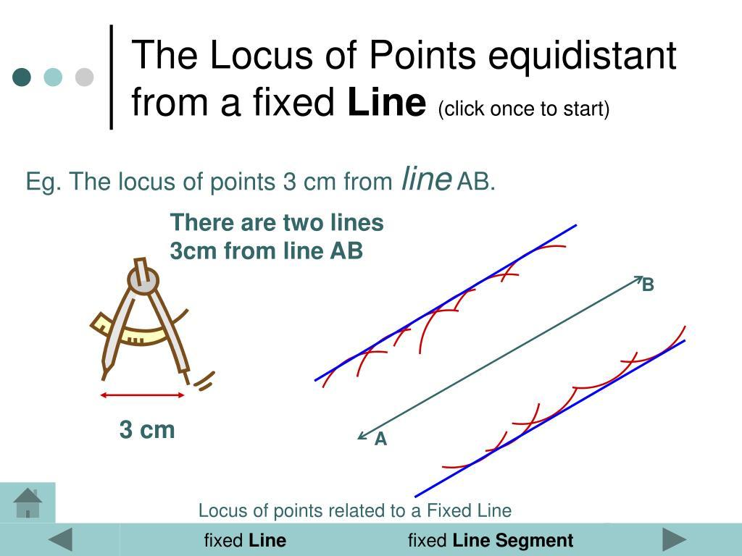
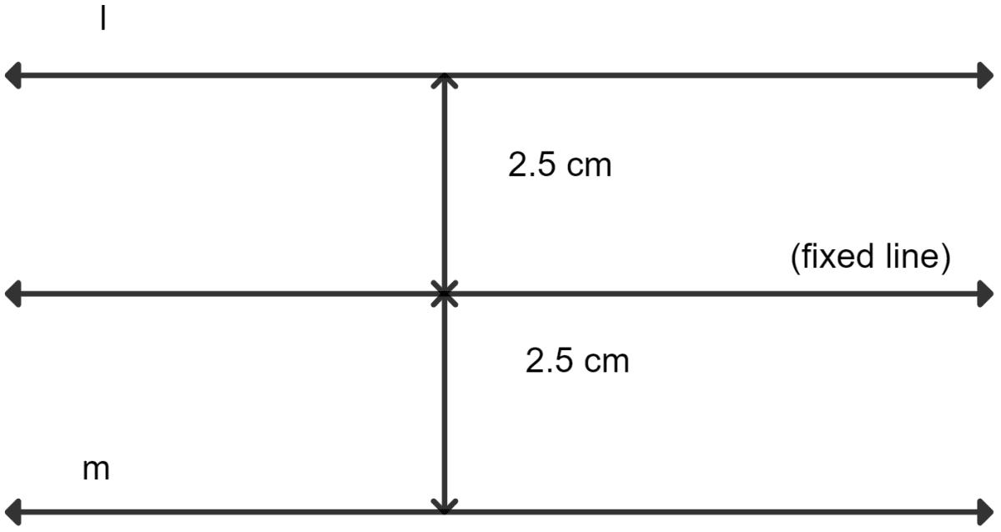

Simple Definition
# Source: AI Source: Provided by: [Data Path: Persons Table -> ID Column: 1, Name_En Column: Motasem Essam] -> From: [ChatGPT] on [7/25/2026]
The locus of points at a fixed distance from a line is two lines parallel to the given line, one on each side, at the specified distance.
If the fixed line is $l$and the distance is $d$:
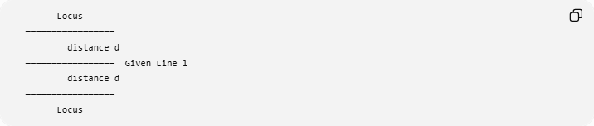
Locus
─────────────────
distance d
───────────────── Given Line l
distance d
─────────────────
Locus
Therefore:
$$\boxed{\text{Fixed Distance from a Line}→\text{Two Parallel Lines}}$$

Fundamental Concept
# Source: AI Source: Provided by: [Data Path: Persons Table -> ID Column: 1, Name_En Column: Motasem Essam] -> From: [ChatGPT] on [7/25/2026]
Suppose $l$is the given line.
We want all points $P$satisfying:
$$d\left(P , l\right)=d$$
where $d$is a fixed positive number.
A point can be exactly $d$units from $l$on either side.
Therefore, there are two sets of points:
- Points at distance $d$on one side of $l$.
- Points at distance $d$on the other side of $l$.
Each set forms a line parallel to $l$.
Hence:
$$\boxed{\text{The complete locus consists of two parallel lines.}}$$

Main Structure
# Source: AI Source: Provided by: [Data Path: Persons Table -> ID Column: 1, Name_En Column: Motasem Essam] -> From: [ChatGPT] on [7/25/2026]
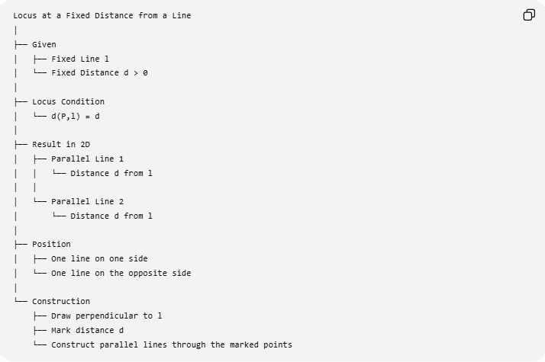
Locus at a Fixed Distance from a Line
│
├── Given
│ ├── Fixed Line l
│ └── Fixed Distance d > 0
│
├── Locus Condition
│ └── d(P,l) = d
│
├── Result in 2D
│ ├── Parallel Line 1
│ │ └── Distance d from l
│ │
│ └── Parallel Line 2
│ └── Distance d from l
│
├── Position
│ ├── One line on one side
│ └── One line on the opposite side
│
└── Construction
├── Draw perpendicular to l
├── Mark distance d
└── Construct parallel lines through the marked points

Why Are the Locus Lines Parallel?
# Source: AI Source: Provided by: [Data Path: Persons Table -> ID Column: 1, Name_En Column: Motasem Essam] -> From: [ChatGPT] on [7/25/2026]
The shortest distance from a point to a line is measured perpendicularly.
Suppose $P$is at distance $d$from $l$.
Draw:
$$PH⊥l$$
with:
$$PH=d.$$
Moving $P$along a direction parallel to $l$does not change its perpendicular distance from $l$.
Therefore, all such points form a line parallel to $l$.
The same happens on the opposite side.
Thus:
$$\boxed{\text{Two parallel lines form the complete locus.}}$$

Example 1 — Horizontal Line
# Source: AI Source: Provided by: [Data Path: Persons Table -> ID Column: 1, Name_En Column: Motasem Essam] -> From: [ChatGPT] on [7/25/2026]
Suppose the given line is:
$$y=0$$
which is the $x$-axis.
We want all points at a fixed distance:
$$d=3$$
from the $x$-axis.
For $P=\left(x , y\right)$, the distance from the $x$-axis is:
$$∣y∣.$$
Therefore:
$$∣y∣=3.$$
This gives:
$$y=3$$
or:
$$y=-3.$$
Hence the locus is:
$$\boxed{y=3 \text{or} y=-3}$$
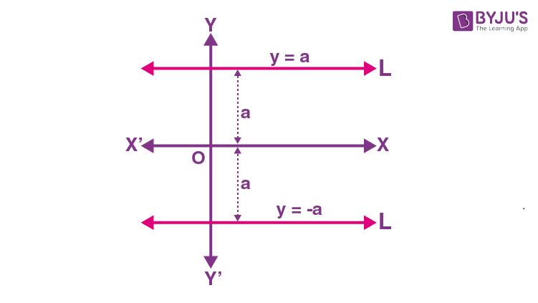
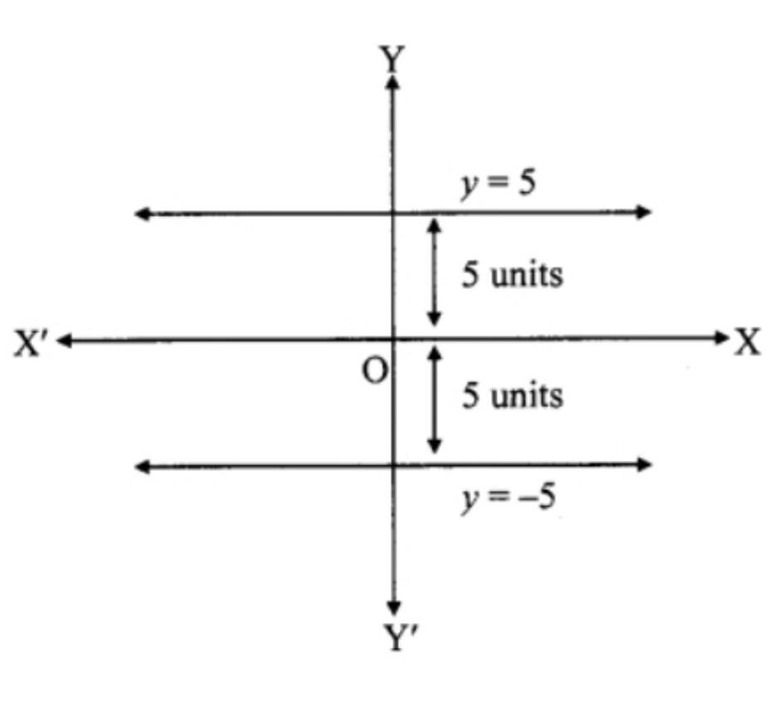
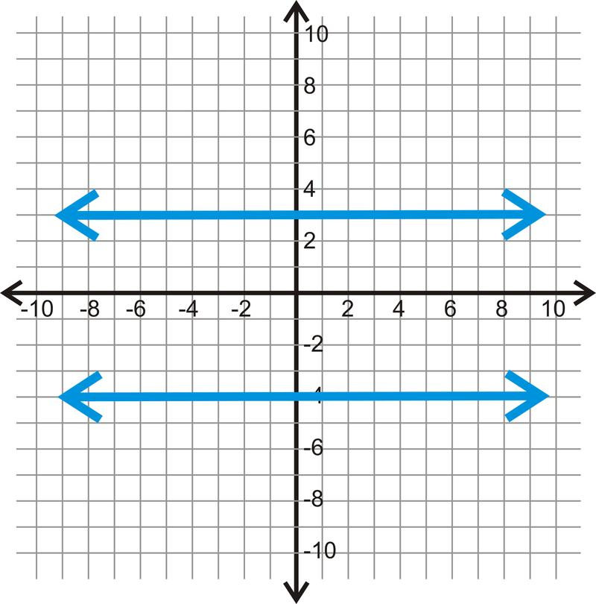
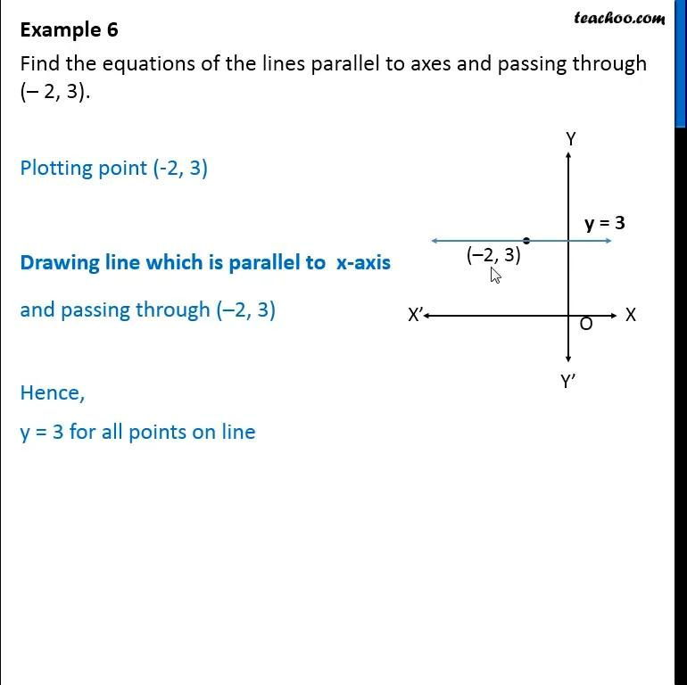

Example 2 — Vertical Line
# Source: AI Source: Provided by: [Data Path: Persons Table -> ID Column: 1, Name_En Column: Motasem Essam] -> From: [ChatGPT] on [7/25/2026]
Suppose the given line is:
$$x=2.$$
We want points at distance:
$$d=4.$$
For a point $P=\left(x , y\right)$, the distance from $x=2$is:
$$∣x-2∣.$$
Therefore:
$$∣x-2∣=4.$$
So:
$$x-2=4$$
or:
$$x-2=-4.$$
Hence:
$$x=6$$
or:
$$x=-2.$$
Therefore the locus is:
$$\boxed{x=6 \text{or} x=-2}$$
Both lines are parallel to the original line $x=2$.

Example 3 — General Line
# Source: AI Source: Provided by: [Data Path: Persons Table -> ID Column: 1, Name_En Column: Motasem Essam] -> From: [ChatGPT] on [7/25/2026]
Suppose the given line is:
$$3x+4y-10=0.$$
We want the locus of points at distance:
$$d=2.$$
The distance from $P=\left(x , y\right)$to the line is:
$$\frac{∣3x+4y-10∣}{\sqrt{3^{2}+4^{2}}}.$$
Since:
$$\sqrt{9+16}=5,$$
we require:
$$\frac{∣3x+4y-10∣}{5}=2.$$
Therefore:
$$∣3x+4y-10∣=10.$$
This gives two equations:
$$3x+4y-10=10$$
and:
$$3x+4y-10=-10.$$
Therefore:
$$\boxed{3x+4y-20=0}$$
or:
$$\boxed{3x+4y=0}.$$
These are the two parallel lines forming the locus.

General Coordinate Formula
# Source: AI Source: Provided by: [Data Path: Persons Table -> ID Column: 1, Name_En Column: Motasem Essam] -> From: [ChatGPT] on [7/25/2026]
For the given line:
$$\boxed{ax+by+c=0}$$
the perpendicular distance from:
$$P=\left(x , y\right)$$
to the line is:
$$d\left(P , l\right)=\frac{∣ax+by+c∣}{\sqrt{a^{2}+b^{2}}}.$$
For a fixed distance $r>0$:
$$\frac{∣ax+by+c∣}{\sqrt{a^{2}+b^{2}}}=r.$$
Therefore:
$$∣ax+by+c∣=r\sqrt{a^{2}+b^{2}}.$$
The absolute value produces two equations:
$$\boxed{ax+by+c=r\sqrt{a^{2}+b^{2}}}$$
and:
$$\boxed{ax+by+c=-r\sqrt{a^{2}+b^{2}}}$$
These are the two parallel lines forming the locus.

Geometric Construction
# Source: AI Source: Provided by: [Data Path: Persons Table -> ID Column: 1, Name_En Column: Motasem Essam] -> From: [ChatGPT] on [7/25/2026]
The locus can also be constructed using a straightedge and compass.
Steps
- Start with the given line $l$.
- Choose any point $A$on $l$.
- Construct a perpendicular to $l$through $A$.
- Mark a point $P$on the perpendicular such that:
$$AP=d.$$
- Through $P$, construct a line parallel to $l$.
- Repeat on the opposite side of $l$.
The two constructed parallel lines are the locus.
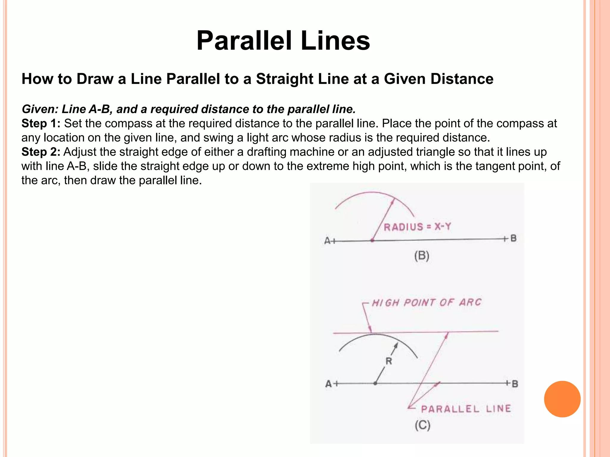
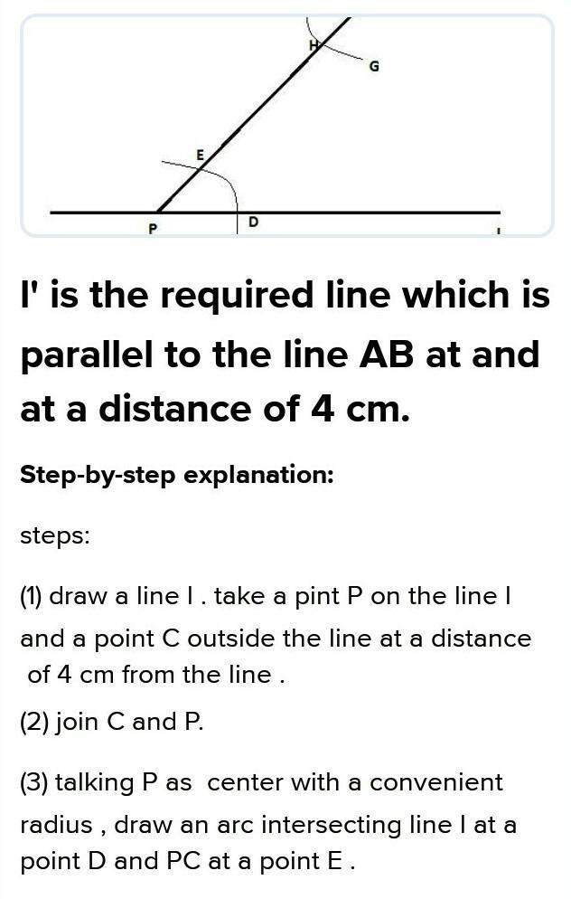
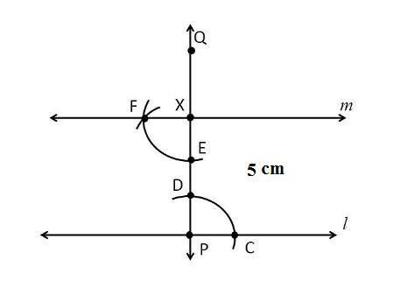
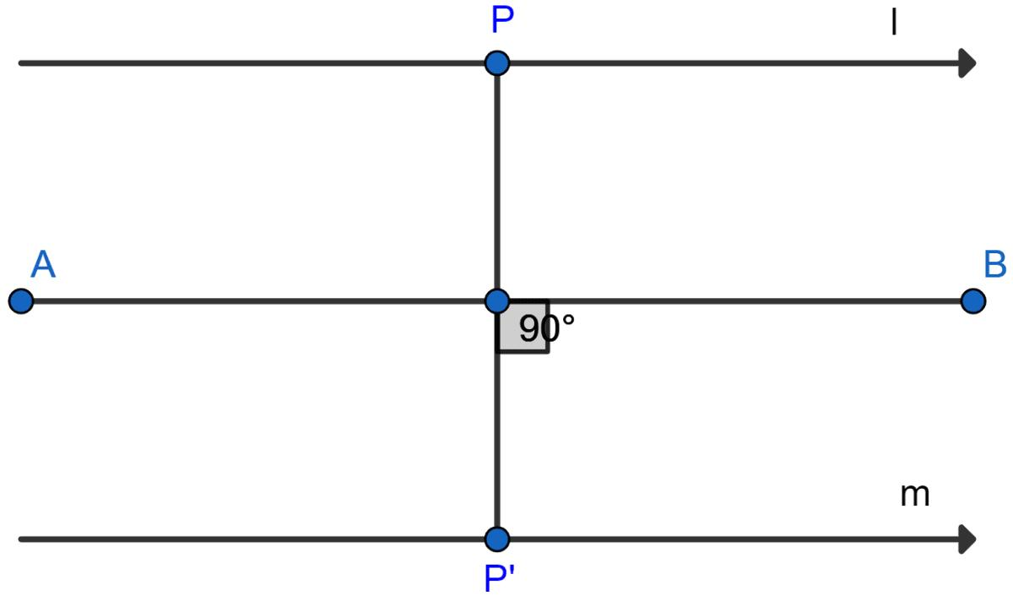

Why Are There Two Lines?
# Source: AI Source: Provided by: [Data Path: Persons Table -> ID Column: 1, Name_En Column: Motasem Essam] -> From: [ChatGPT] on [7/25/2026]
The condition is:
$$d\left(P , l\right)=d$$
not:
$$P\text{ is on a particular side of }l.$$
A point can be distance $d$from the line on either side.
Therefore:
$$\boxed{\text{Two sides}→\text{Two parallel locus lines}}$$
If a problem specifies one particular side, then only one of the two parallel lines is included.

One-Sided Locus
# Source: AI Source: Provided by: [Data Path: Persons Table -> ID Column: 1, Name_En Column: Motasem Essam] -> From: [ChatGPT] on [7/25/2026]
Suppose:
Find the locus of points 5 cm from line $l$and lying above $l$.
Then only the parallel line 5 cm above $l$is part of the locus.
So:
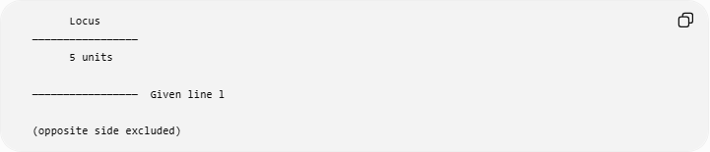
Locus
─────────────────
5 units

───────────────── Given line l

(opposite side excluded)
Thus:
$$\boxed{\text{One-sided condition}→\text{One parallel line}}$$
while:
$$\boxed{\text{Both sides allowed}→\text{Two parallel lines}}$$

Fixed Distance vs. At Most a Fixed Distance
# Source: AI Source: Provided by: [Data Path: Persons Table -> ID Column: 1, Name_En Column: Motasem Essam] -> From: [ChatGPT] on [7/25/2026]
These conditions produce different loci.
Exactly a fixed distance
$$\boxed{d\left(P , l\right)=r}$$
produces two parallel lines.
Less than the fixed distance
$$\boxed{d\left(P , l\right)<r}$$
produces the open strip between the two parallel lines.
At most the fixed distance
$$\boxed{d\left(P , l\right)≤r}$$
produces the closed strip between and including the two parallel lines.
Greater than the fixed distance
$$\boxed{d\left(P , l\right)>r}$$
produces the two outer regions outside the strip.
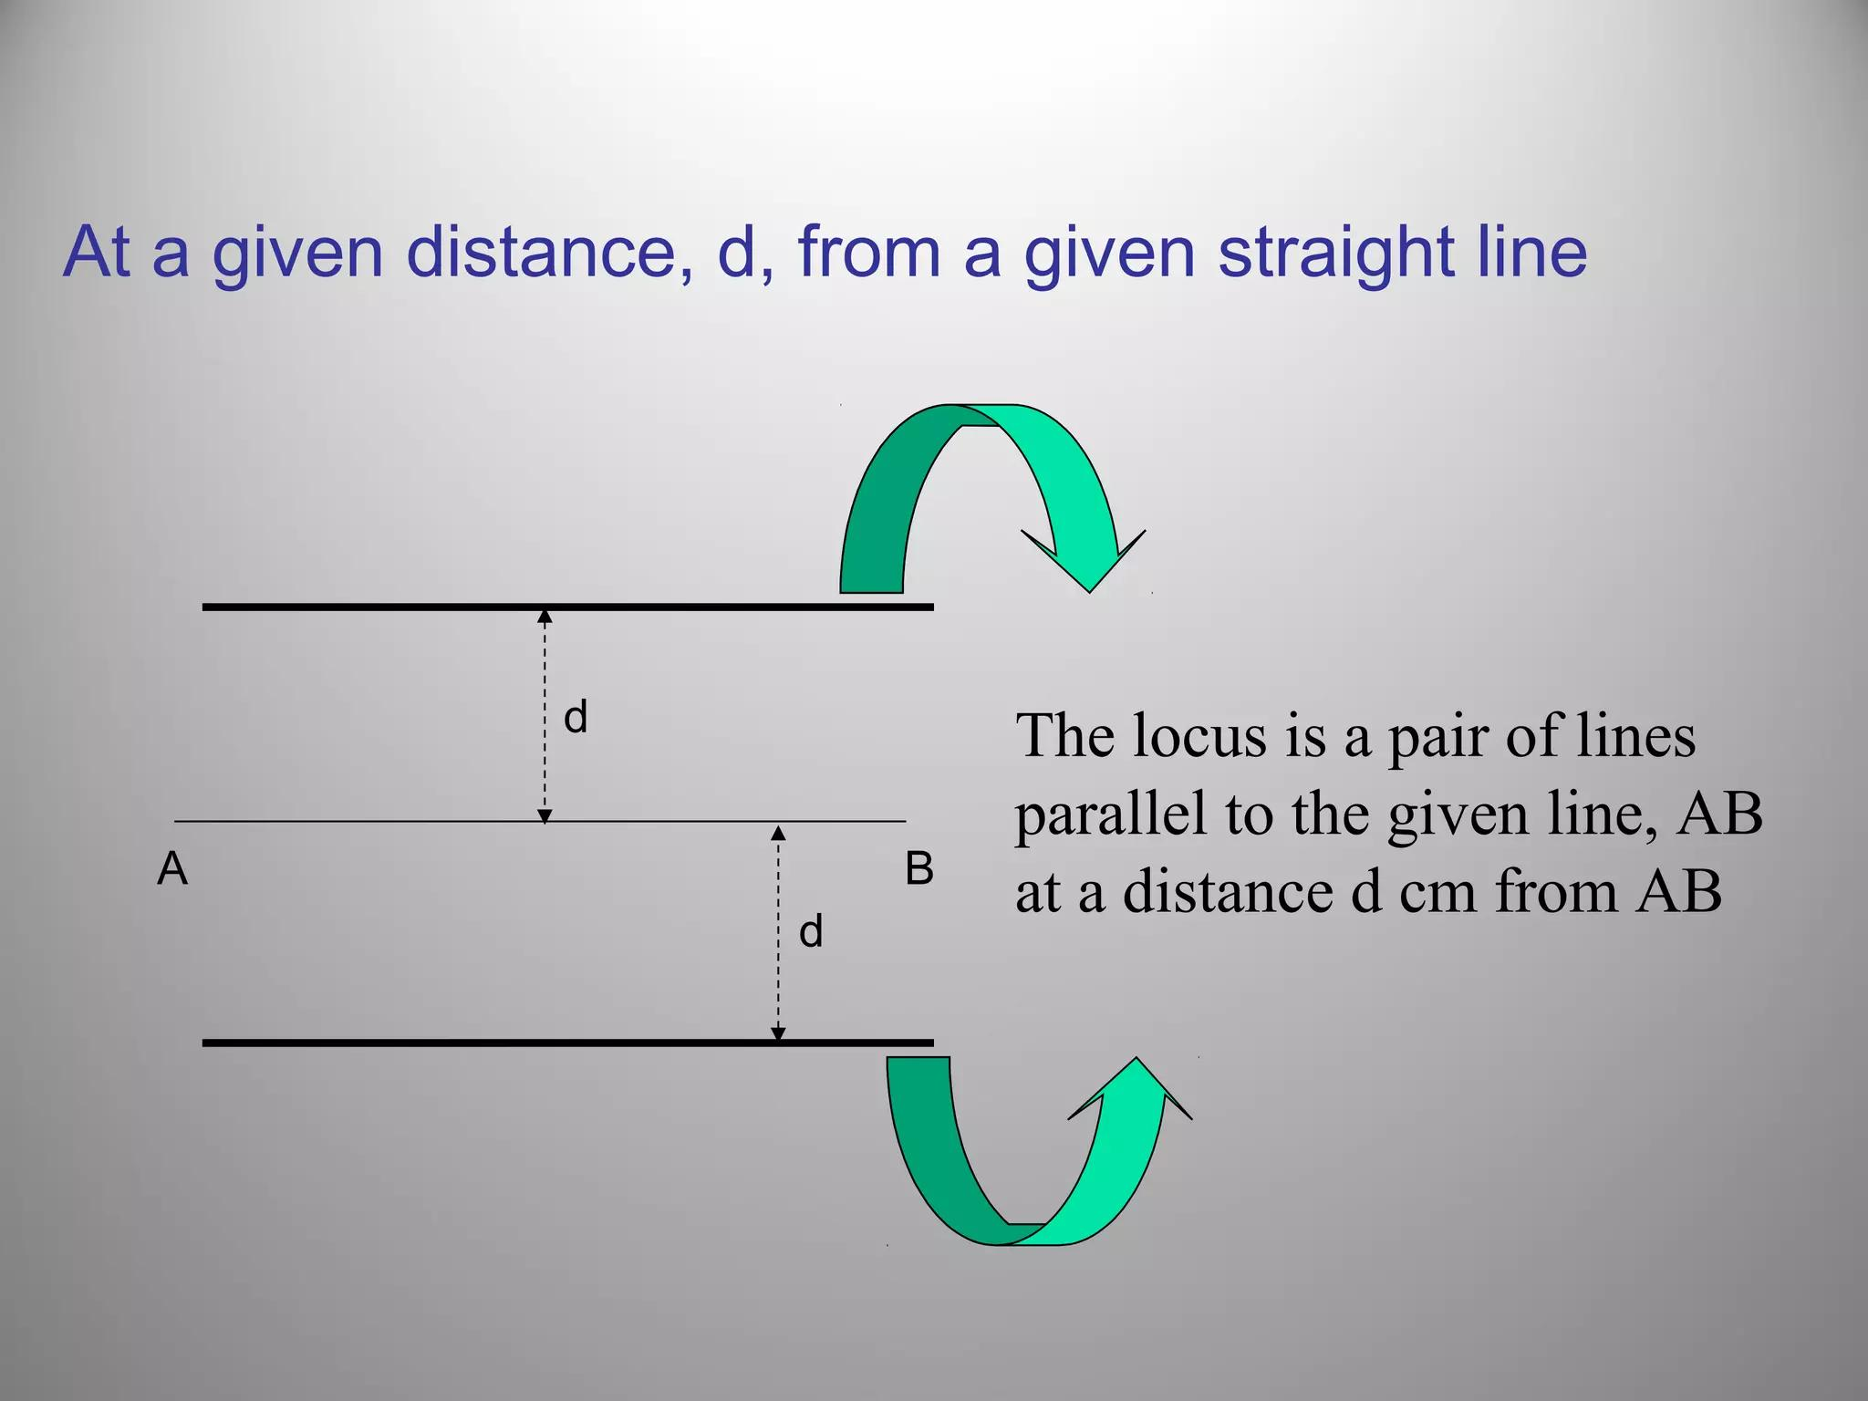
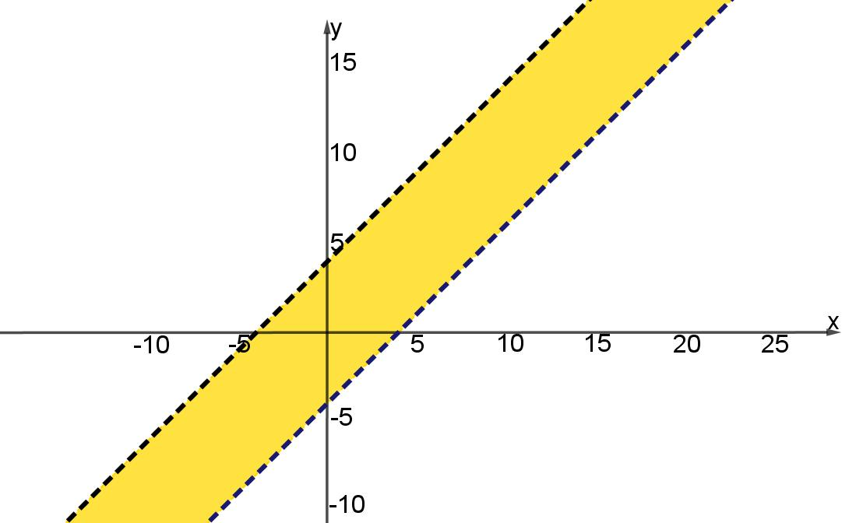

Important Distinction: Locus vs. Region
# Source: AI Source: Provided by: [Data Path: Persons Table -> ID Column: 1, Name_En Column: Motasem Essam] -> From: [ChatGPT] on [7/25/2026]
This distinction is important.
Exact distance
$$d\left(P , l\right)=r$$
→ two lines.
Distance less than $r$
$$d\left(P , l\right)<r$$
→ a region (open strip).
Distance at most $r$
$$d\left(P , l\right)≤r$$
→ a closed region (closed strip).
So:
$$\boxed{\text{Equality}→\text{Boundary}}$$
while:
$$\boxed{\text{Inequality}→\text{Region}}$$

Relation to Parallel Lines
# Source: AI Source: Provided by: [Data Path: Persons Table -> ID Column: 1, Name_En Column: Motasem Essam] -> From: [ChatGPT] on [7/25/2026]
The locus provides a natural way to construct parallel lines.
Given:
- a line $l$,
- a fixed distance $d$,
the two lines at distance $d$from $l$are necessarily parallel to $l$.
Thus:
$$\boxed{\text{Fixed Distance from a Line}→\text{Parallel Lines}}$$
Conversely, two distinct parallel lines determine a constant distance between them.

Relation to Equidistant Points from Two Parallel Lines
# Source: AI Source: Provided by: [Data Path: Persons Table -> ID Column: 1, Name_En Column: Motasem Essam] -> From: [ChatGPT] on [7/25/2026]
Suppose two parallel lines are:
$$l_{1}$$
and:
$$l_{2}.$$
The locus of points equidistant from both lines is the line exactly halfway between them.
This is related to, but different from, the current locus.
Fixed distance from one line
$$d\left(P , l\right)=r$$
→ two parallel lines.
Equal distance from two parallel lines
$$d\left(P , l_{1}\right)=d\left(P , l_{2}\right)$$
→ one middle parallel line.
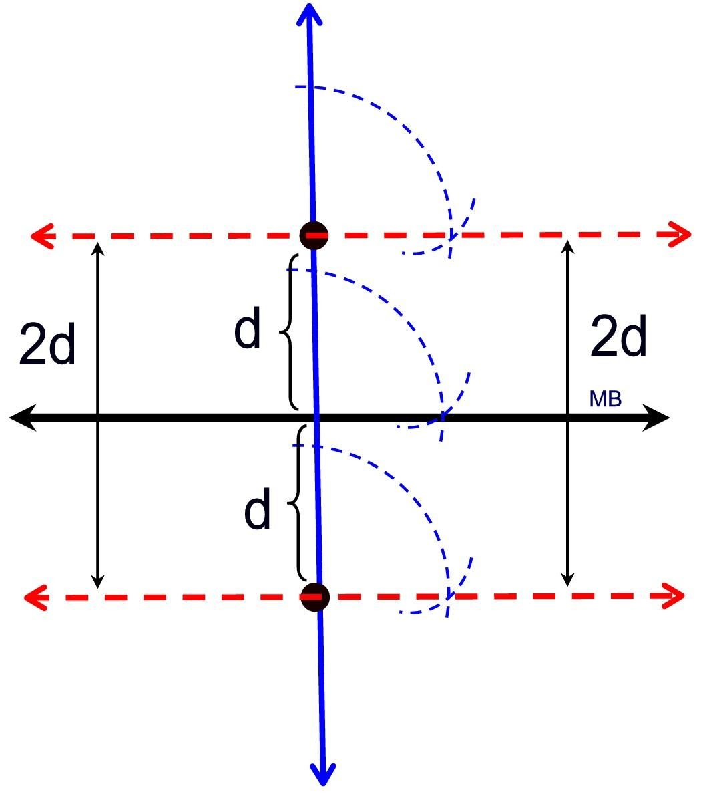

Relation to Distance from a Point
# Source: AI Source: Provided by: [Data Path: Persons Table -> ID Column: 1, Name_En Column: Motasem Essam] -> From: [ChatGPT] on [7/25/2026]
Compare:
Fixed distance from a point
$$PA=r$$
The locus is:
$$\boxed{\text{Circle}}$$
Fixed distance from a line
$$d\left(P , l\right)=r$$
The locus is:
$$\boxed{\text{Two parallel lines}}$$
The difference comes from the geometry of the reference object.
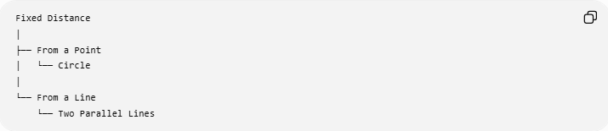
Fixed Distance
│
├── From a Point
│ └── Circle
│
└── From a Line
└── Two Parallel Lines

Relation to a Triangle
# Source: AI Source: Provided by: [Data Path: Persons Table -> ID Column: 1, Name_En Column: Motasem Essam] -> From: [ChatGPT] on [7/25/2026]
A fixed-distance-from-a-line locus can appear naturally in triangle problems.
Suppose $BC$is a fixed side of a triangle and the altitude from $A$to $BC$must have a fixed length $h$.
Then $A$must lie on one of the two lines parallel to $BC$at distance $h$.
For example:
$$d\left(A , BC\right)=h.$$
Therefore:
$$\boxed{A\text{ lies on one of two parallel lines to }BC}$$
This can be used to construct triangles with a prescribed base and altitude.

Relation to Area
# Source: AI Source: Provided by: [Data Path: Persons Table -> ID Column: 1, Name_En Column: Motasem Essam] -> From: [ChatGPT] on [7/25/2026]
For a triangle with fixed base $b$:
$$A=\frac{1}{2}bh.$$
If the altitude $h$is fixed, then:
$$A=\frac{1}{2}bh$$
is fixed.
Therefore, the locus of possible positions of the third vertex $C$, while keeping base $AB$fixed and altitude $h$fixed, consists of two lines parallel to $AB$:
$$\boxed{d\left(C , AB\right)=h}$$
This is a useful application of the locus concept.

Important Properties
# Source: AI Source: Provided by: [Data Path: Persons Table -> ID Column: 1, Name_En Column: Motasem Essam] -> From: [ChatGPT] on [7/25/2026]
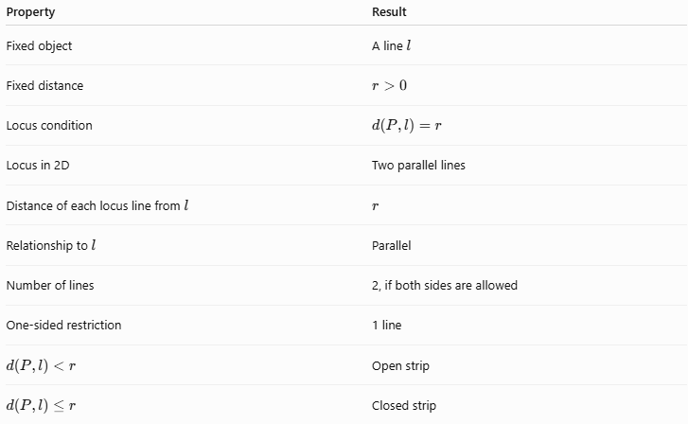
Property | Result
Fixed object | A line $l$
Fixed distance | $$r>0$$
Locus condition | $$d\left(P , l\right)=r$$
Locus in 2D | Two parallel lines
Distance of each locus line from $l$ | $$r$$
Relationship to $l$ | Parallel
Number of lines | 2, if both sides are allowed
One-sided restriction | 1 line
$$d\left(P , l\right)<r$$ | Open strip
$$d\left(P , l\right)≤r$$ | Closed strip

Classification
# Source: AI Source: Provided by: [Data Path: Persons Table -> ID Column: 1, Name_En Column: Motasem Essam] -> From: [ChatGPT] on [7/25/2026]
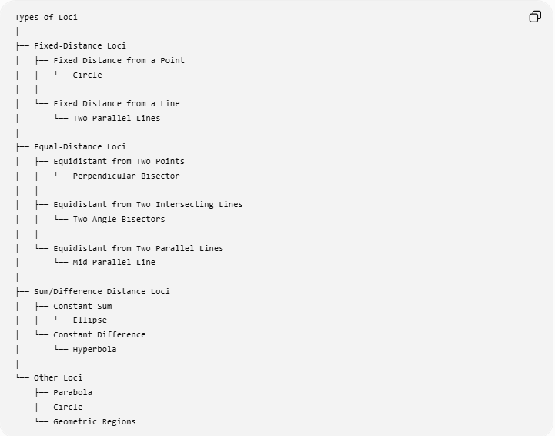
Types of Loci
│
├── Fixed-Distance Loci
│ ├── Fixed Distance from a Point
│ │ └── Circle
│ │
│ └── Fixed Distance from a Line
│ └── Two Parallel Lines
│
├── Equal-Distance Loci
│ ├── Equidistant from Two Points
│ │ └── Perpendicular Bisector
│ │
│ ├── Equidistant from Two Intersecting Lines
│ │ └── Two Angle Bisectors
│ │
│ └── Equidistant from Two Parallel Lines
│ └── Mid-Parallel Line
│
├── Sum/Difference Distance Loci
│ ├── Constant Sum
│ │ └── Ellipse
│ └── Constant Difference
│ └── Hyperbola
│
└── Other Loci
├── Parabola
├── Circle
└── Geometric Regions

Key Formulas
# Source: AI Source: Provided by: [Data Path: Persons Table -> ID Column: 1, Name_En Column: Motasem Essam] -> From: [ChatGPT] on [7/25/2026]
For:
$$l:ax+by+c=0$$
the distance from $P=\left(x , y\right)$to $l$is:
$$\boxed{d\left(P , l\right)=\frac{∣ax+by+c∣}{\sqrt{a^{2}+b^{2}}}}$$
For fixed distance $r$:
$$\boxed{\frac{∣ax+by+c∣}{\sqrt{a^{2}+b^{2}}}=r}$$
giving:
$$\boxed{ax+by+c=±r\sqrt{a^{2}+b^{2}}}$$
Therefore, the complete locus is two parallel lines.

Summary
# Source: AI Source: Provided by: [Data Path: Persons Table -> ID Column: 1, Name_En Column: Motasem Essam] -> From: [ChatGPT] on [7/25/2026]
$$\boxed{\text{Fixed Line}+\text{Fixed Perpendicular Distance}→\text{Two Parallel Lines}}$$
The essential condition is:
$$\boxed{d\left(P , l\right)=r}$$
where $r>0$.
The two sides of the original line produce two locus lines:
$$\boxed{\text{Locus}=l_{1}∪l_{2}}$$
with:
$$l_{1}∥l, l_{2}∥l$$
and:
$$d\left(l_{1} , l\right)=d\left(l_{2} , l\right)=r.$$

Conclusion
# Source: AI Source: Provided by: [Data Path: Persons Table -> ID Column: 1, Name_En Column: Motasem Essam] -> From: [ChatGPT] on [7/25/2026]
The locus of points at a fixed distance from a line is two parallel lines, one on each side of the given line, when both sides are allowed. This locus is closely connected to parallel-line construction, strips, triangle altitudes, fixed-area problems, and distance inequalities.

